**Supplementary material**

**Severe Mental Illness and the risk of diabetes complications. A Nationwide Register-based Cohort Study**

Stine H. Scheuer, Vanja Kosjerina, Nanna Lindekilde, Frans Pouwer, Bendix Carstensen, Marit E. Jørgensen, Michael E. Benros, Gregers S. Andersen.

**Table 1)** International classification of disease (ICD-10 and ICD-8) codes that make up the severe mental illnesses.

|  |  |  |
| --- | --- | --- |
| **Disease** | **ICD-10** | **ICD-8** |
| Schizophrenia (including schizophrenia and schizophrenia spectrum disorder) | F20-F29 | 295.x9, 296.89, 297.x9, 298.29– 298.99, 299.04, 299.05, 299.09, 301.83 |
| Bipolar disorder | F30-F31 | 296.19, 296.39, 298.19 |
| Depression (including depression and other mood disorders). | F32-F33 | 296.09, 296.29, 298.09, 300.49 |

**Table 2)** International classification of disease (ICD-10) codes, Danish procedure codes and Nomenclature for Properties and Units (NPU) codes that make up the diabetes complications.

|  |  |  |  |  |
| --- | --- | --- | --- | --- |
| **Disease** | | **ICD-10** | **Procedures codes** | **NPU-codes** |
| Non-fatal Cardiovascular Disease (CVD) | |  |  |  |
| *Atrial fibrillation* | I48 | KFPD00, KFPD96 |  |
| *Heart failure* | I110, I50 |  |  |
| *Hypertensive disease* | I10, I11, I12, I13, I15 |  |  |
| *Non-Myocardial infarction ischemic heart disease* | I20, I25 |  |  |
| *Myocardial infarction* | I21, I23, I24 | KFNA00, KFNA10, KFNA20, KFNA96, KFNB00,KFNB20, KFNB96, KFNC10, KFNC20, KFNC30, KFNC40, KFNC50, KFNC60, KFNC96, KFND10, KFND20, KFND96, KFNE00, KFNE10, KFNE20, KFNE96, KFNF00, KFNF10, KFNF20, KFNF30, KFNF96, KFNG00, KFNG00A, KFNG00B, KFNG00C, KFNG02, KFNG02A, KFNG05, KFNG05A, KFNG10, KFNG12, KFNG30, KFNG40, KFNG96 |  |
| *Cerebrovascular disease (inclusive stroke)* | | I60, I61, I63, I64, G45 |  |  |
| *Macrovascular atherosclerotic disease* | | I70, I71, I739A, I739C |  |  |
| Fatal CVD (death from CVD) | |  |  |  |
| *Atrial fibrillation* | | I48 |  |  |
| *Heart failure* | | I110, I50 |  |  |
| *Hypertensive disease* | | I10, I11, I12, I13, I15 |  |  |
| *Non-MI Ischemic heart disease* | | I20, I25 |  |  |
| *Myocardial infarction* | | I21, I23, I24 |  |  |
| *Cerebrovascular disease (inclusive stroke)* | | I60, I61, I63, I64, G45 |  |  |
| *Macrovascular atherosclerotic disease* | | I70, I71, I739A, I739C |  |  |
| Nephropathy* | |  |  |  |
| *End-stage Chronic kidney disease (CDK)* | N185 | BJFD, BJFZ, KJAK10, KJAK11, KJAK13, KJAK14, KKAS00, KKAS10, KKAS20, KKAS40, KKAS41, KKAS50, KKAS60, KKAS61, KKAS70, KKAS96, KKAS97, KPBL10, KPBL10A, KPBL20, KPBL20A, KPBL30, KPBL30A, KPBL99 | DNK35131 DNK35301 DNK35302 DNK35303 |
| *Moderate CDK* | N183, N189 |  | DNK35131 DNK35301 DNK35302 DNK35303 |
| *Severe CDK* | N184 |  | DNK35131 DNK35301 DNK35302 DNK35303 |
| Retinopathy | | H33, H352, H360, H368D, H420, H43 | BCDE, KCKB00, KCKB10, KCKB99, KCKC, KCKD, KCKE |  |
| Amputation | |  |  |  |
| *Upper amputation* | | Z896, Z896A, Z897 | KNFQ09, KNFQ19, KNFQ99 |  |
| *Medium amputation* | | Z895, Z895A, Z895B | KNGQ09, KNGQ19, KNGQ99 |  |
| *Minor amputation* | | Z894, Z894A | KNHQ00, KNHQ01, KNHQ02, KNHQ03, KNHQ05, KNHQ06, KNHQ07, KNHQ08, KNHQ10-17 KNHQ99 |  |
| Non-CVD related mortality ** | | All causes of death except ICD codes related to fatal CVD (see above) |  |  |

* The diagnoses of moderate, severe and end stage chronic kidney disease based on NPU-codes are defined as two measurements of eGFR below 60, 30, resp. 15 with at least 60 days interval. The date of the complication is defined as the date of the second measurement beyond the threshold.   
** As we only had information on cause of death until 31.12.2017, we only examined non-fatal and fatal CVD and the non-CVD related mortality until 31.12.2017.

**Table 3)** International classification of disease (ICD-10 and ICD-8) codes that make up the substance use disorder.

|  |  |  |
| --- | --- | --- |
| **Disease** | **ICD-10** | **ICD-8** |
| Substance use disorder | F10-F16, F18, F19 | 291, 303, 304 |

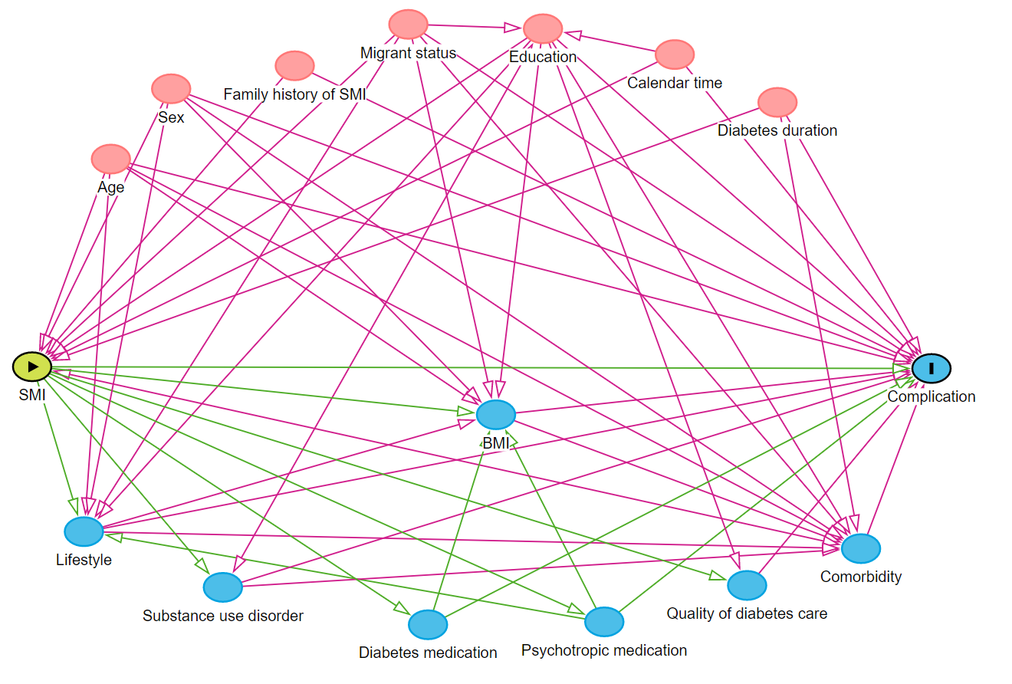

**Figure 1**. Directed acyclic graph illustrating the causal network of association between SMI and diabetes complications applied to identify potential confounders. The identified confounders were age, sex, diabetes duration, calendar time, education, migrant status, family history of SMI and the identified mediating factors were lifestyle, substance use disorder, BMI, diabetes medication, psychotropic medication, quality of diabetes care and comorbidity. The analyzes were only adjusted for the following two mediating factors: Substance use disorder and comorbidity. Of the confounders the analysis were not adjusted for family history of SMI because we did not have this information.

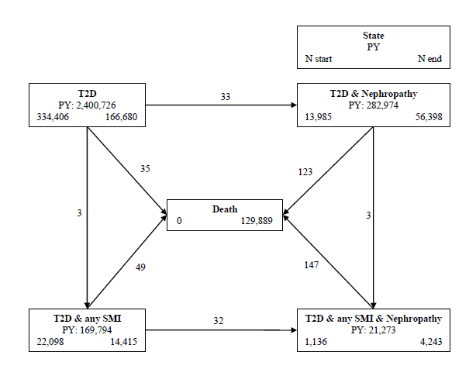

**Figure 2**. Patient flow in the study. Multistate model for any SMI and nephropathy. The numbers on the arrows are transitions per 1000 person-years of follow-up (overall IR). The number in the boxes are; person years of follow-up (PY, middle), the number of persons beginning in the state (N start, bottom left), the number of persons ending their follow-up in the state (N end, bottom right).

Abbreviations: T2D: Type 2 diabetes, SMI: Severe mental illness

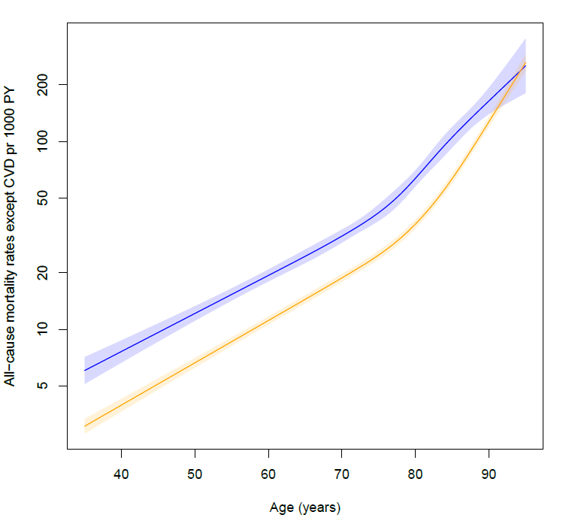

Without SMI  
SMI

**Figure 3. Non-CVD related mortality rates per 1000 person-years by age in persons with SMI (blue) and without SMI (yellow).** Incidence rates and incidence rate ratios are shown on a log scale. Data is shown for men diagnosed in 2013, with a diabetes duration of 5 years, a low educational level and of Danish origin. The shaded areas indicate 95% confidence intervals.

**Table 4.** Subgroups of cardiovascular disease complications in persons with and without severe mental illness. Person years, number of events, incidence rates and incidence rate ratios (IRR) (95% confidence intervals (CI)) in persons with severe mental illness compared to persons without severe mental illnessµ.

|  |  |  |  |  |  |  |
| --- | --- | --- | --- | --- | --- | --- |
|  | **Person years of follow-up** | **No. of events** | **Crude incidence rate per 1000 person years of follow-up** | **Model 1**  **IRR (95% CI)** | **Model 2**  **IRR (95% CI)** | **Model 3**  **IRR (95% CI)** |
| **Any severe mental illness** |  |  |  |  |  |  |
| Ischemic heart disease* | 154,757 | 2,393 | 15.5 | 1.07 (1.03 - 1.12) | 1.11 (1.06 - 1.15) | 1.06 (1.02 - 1.11) |
| Cerebrovascular disease | 169,887 | 2,111 | 12.5 | 1.34 (1.28 - 1.40) | 1.38 (1.32 - 1.45) | 1.25 (1.19 - 1.31) |
| Macrovascular atherosclerotic disease | 179,849 | 412 | 2.5 | 1.13 (1.07 - 1.19) | 1.14 (1.08 - 1.21) | 1.01 (0.96 - 1.08) |
| **Without severe mental illness** |  |  |  |  |  |  |
| Ischemic heart disease* | 2,154,797 | 37,147 | 17.2 | 1 [reference] | 1 [reference] | 1 [reference] |
| Cerebrovascular disease | 2,422,077 | 27,656 | 11.4 | 1 [reference] | 1 [reference] | 1 [reference] |
| Macrovascular atherosclerotic disease | 2,519,592 | 6,417 | 2.5 | 1 [reference] | 1 [reference] | 1 [reference] |

* Ischemic heart disease includes non-myocardial infarction and myocardial infarction.  
µ Model 1: Adjusted for age, sex, diabetes duration and calendar year. Model 2: Additionally, adjusted for education and migrant status. Model 3: Additionally, adjusted for substance use disorder and comorbidity.

**Table 5.** HbA1c and low-density lipoprotein (LDL) cholesterol levels at type 2 diabetes diagnosis* in persons diagnosed with type 2 diabetes from 01.01.2015 – 31.12.2018 excluding persons living in Central Denmark Region (n=54.092).

|  |  |  |  |  |
| --- | --- | --- | --- | --- |
|  | **Total population**  **(n = 54,092)** | **Without severe mental illness**  **(n = 49,662)** | **With severe mental illness**  **(n = 4,430)** | **Missing,**  **n (%)** |
| **HbA1c (mmol/mol)** |  |  |  | 6,363 (12%) |
| Median (IQR) | 51 (16) | 51 (16) | 51 (17) |  |
| **LDL-cholesterol (mmol/l)** |  |  |  | 7,564 (14%) |
| Median (IQR) | 2.5 (1.4) | 2.5 (1.4) | 2.5 (1.4) |  |

*HbA1c and LDL-cholesterol levels measured one year before or one year after the date of type 2 diabetes diagnosis are included. If a person had more than one measurement, the one closest to the diabetes diagnosis was used.   
Both HbA1c and LDL-cholesterol levels were not normally distributed and therefore median and IQR are presented.